How to Schedule a Screening at a
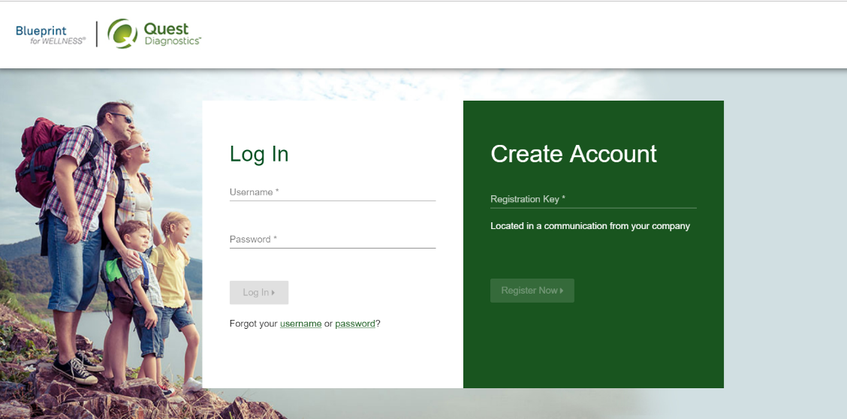
Quest Patient Service Center or Onsite Screening Event

First Time Users – Please complete the steps below:
If this is the first time you are scheduling an appointment, follow the instructions below:
- Click the link here, my.questforhealth.com to access the self-scheduler
- In the “Create Account” section type in the Registration Key: SHBP2020 and click “Register Now”.
- Read the Terms and Conditions and click “Accept & Continue”
- Read the consent language, click on “I accept” then click the “Continue” box
- Type in First Name, Last Name, Date of Birth as it appears on your Insurance card and then select either Employee or Non-Employee
- Create a Username and Password and then confirm password
- Input mailing address and click “Save” to finish creating account
- Click on “Make an Appointment”
- Select desired location
- Choose desired date & time
- Review and confirm information
Existing Users – Please complete the steps below:
If you have previously registered on the Quest site, follow the instructions below:
- In the “Log In” section type in your username and password and click “Log In”
- If you do not remember your username or password, you can use the “forgot your username or password” links provided below the “Log In” button
- Once logged in, click on “Make an Appointment”
- Select desired location
- Choose desired date & time
- Review and confirm information

